**Assignment 1:** Simple SQL Query with a single table with where clause

**Database Name:** Northwind database

**Query:** Create Database Northwind

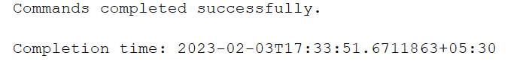**Table Name :**

Products:

* ProductID
* ProductName
* SupplierID
* CategoryID
* QuantityPerUnit
* UnitPrice
* UnitsInStock
* UnitsOnOrder
* ReorderLevel
* Discontinued

**Query:**

CREATE TABLE Products (

ProductID int NOT NULL PRIMARY KEY,

ProductName varchar(40) NOT NULL,

SupplierID int,

CategoryID int,

QuantityPerUnit varchar(20),

UnitPrice real,

UnitsInStock int,

UnitsOnOrder int,

ReorderLevel int,

Discontinued bit NOT NULL,

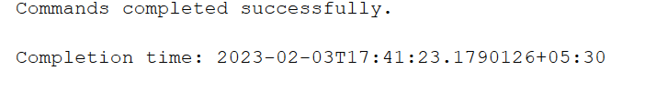);

1. Write a query to get a Product list (id, name, unit price) where current products cost

less than $20.

Ans

**Query:**

select Productid,productname,unitprice from products where unitprice<20;

**Output:**

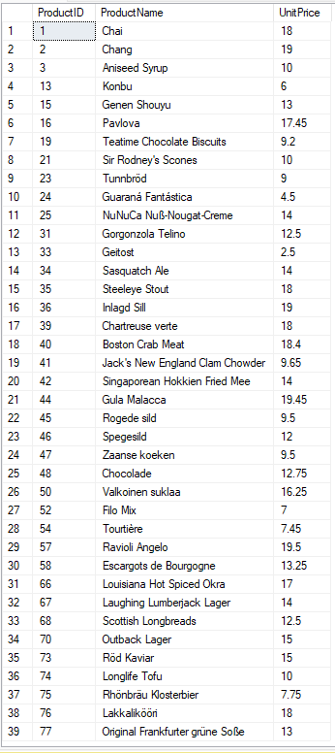

2. Write a query to get Product list (id, name, unit price) where products cost between

$15 and $25

Ans:

**Query:**

select ProductID,ProductName,UnitPrice from products where unitprice>15 and unitPrice<25;

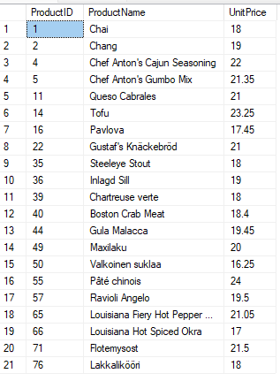Output

3. Write a query to get Product list (name, unit price) of above average price.

Ans:

**Query:**

select ProductName,UnitPrice from products where unitprice>( select AVG(unitprice) from products)

Output:

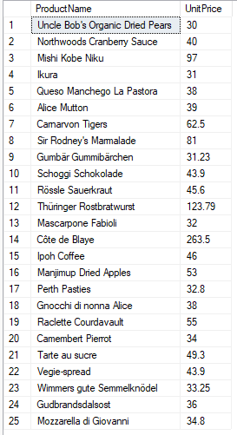

4. Write a query to get Product list (name, unit price) of ten most expensive products

Ans:

**Query:**

Select top 10 ProductName,UnitPrice from products order by unitprice desc

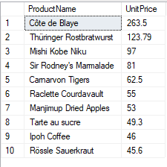Output:

5. Write a query to count current and discontinued products

Ans:

**Query:**

SELECT Discontinued,Count(*) as Product_Count

FROM Products

GROUP BY Discontinued;

Output:

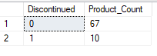

6. Write a query to get Product list (name, units on order ,units in stock) of stock is less than the quantity on order

Ans:

**Query:**

Select ProductName,UnitsOnOrder,UnitsInStock

from products where UnitsInStock<UnitsOnOrder

Output:

